Part 1
(8 marks)
Questions 1 to 8
Read the text carefully in each question. Choose the best answer A, B or C. For each question, mark the correct answer A, B or C on your answer sheet.
“When trees are being cut, the forest is noisy; when trees are growing, the forest is quiet.”
-African Proverb

1. What is the message behind the proverb above?
- Do not destroy the trees in the jungle.
- Let the trees grow to keep the forest quiet.
- If you want a noisy jungle, cut down trees.

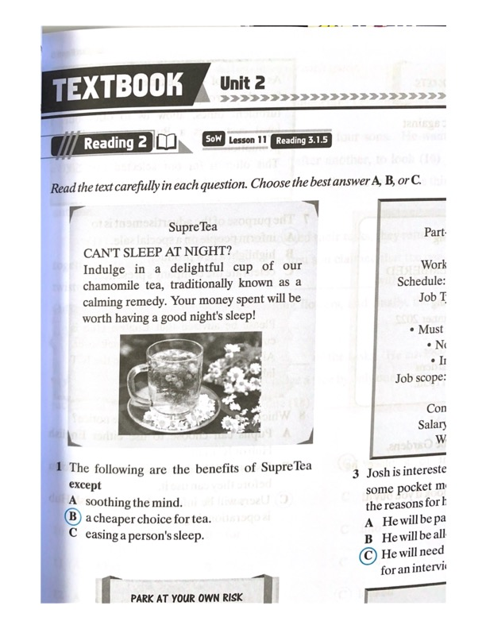

2. The following are the benefits of SupreTea except
- soothing the mind.
- a cheaper choice for tea.
- easing a person’s sleep.
Dear Samantha,
I will need my bicycle today at 3.30 p.m. as I have to go to the school library for a Librarian Meeting. Please hurry back after school and leave it in the garage. Puan Noraini Zaman likes her librarian to be punctual and I wouldn’t want to get into her bad books. Love,
Wendy

3. In the note, the main point of the message is
- Wendy does not want to be late for her meeting.
- Samantha wants to park her bicycle in the garage.
- Wendy wants Samantha to hurry home from school.
KUALA LUMPUR – The police are looking for a young man who ran away while receiving treatment at the general hospital. He suffers from depression and was taken to the hospital on 10 February, Friday. Petaling Jaya OCPD said they received a report that Hasan Bakri ran away on 16 February. The police is urging anyone with information of his whereabouts to contact them immediately. Those with information should call the police hotline on 03-92000222 or go to the nearest police station immediately.

4. The purpose of the news report is
- to urge those with information to contact the police.
- to persuade the missing person to surrender immediately.
- to warn those who have kidnapped Hasan Bakri to surrender.
Careers and Training Fair for SPM and STPM holders will be held at Mines Exhibition Hall A from 10 March to 16 March. Representatives from various local and international universities will be available to assist you to make the suitable choice. There are over 10,000 places available to continue your diploma and degree courses. Meet the professionals in various fields to learn more.

5. The above notice is mainly for
- graduates looking for suitable jobs.
- students who wish to continue their studies.
- professionals who wish to meet SPM and STPM holders.

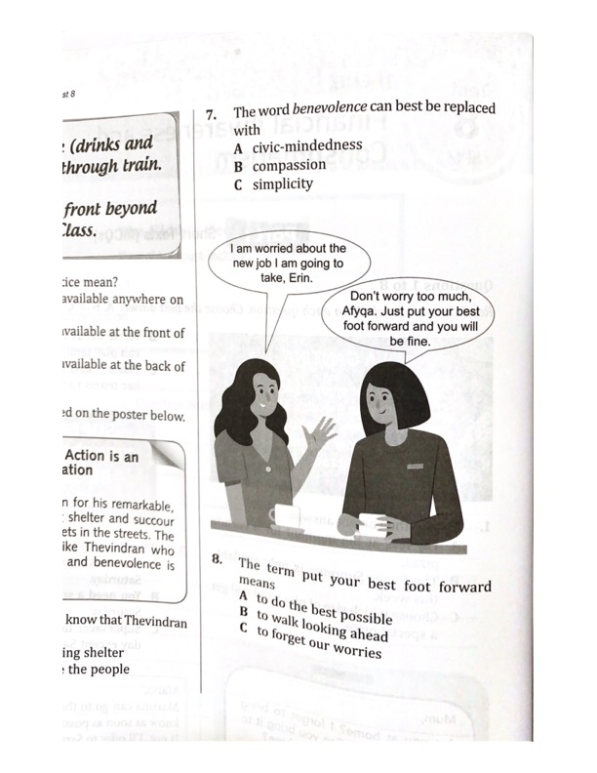
6. The term put your best foot forward means
- to do the best possible.
- to walk looking ahead.
- to forget our worries.

Encik Johari, coach of the national football team says, ‘There are a lot of benefits of doing. Physical activities for teenagers. Even just 30 minutes a day will have a positive impact on you.’
We at All Fitness Club promise that you will get a fit body in no time. By joining us, you will also get expert advice about proper food intake from a certified nutritionist. A healthier and happier you is achievable through exercise and a balanced diet.

7. The purpose of the advertisement is
- to introduce a new fitness club to teenagers.
- to persuade teenagers to seek a certified nutritionist.
- to inform teenagers about the benefits of exercise and nutrition.
RAWANG – The state government is forking out RM1 million for two high-tech drones. They will be used to monitor rivers in Selangor.
‘These drones are able to collect water samples even in remote areas. They can detect individuals in the dark. If there are any suspicious activities, we will be given early warning,’ said a water management executive.
Authorities are taking active steps to prevent river pollution activities from happening again by using advanced technology and imposing heavier penalties on guilty parties.

8. Which of the following is true about the news?
- The drones cost RM1 million each.
- Water pollution has not happened before at water sources.
- Low lighting does not affect the drones’ ability to monitor the rivers.

Part 2
(10 marks)
Questions 9 to 18
Read the text below and choose the best word for each space. For each question, mark the correct letter A, B, C or D on your answer sheet.
How soon is too soon?
It is said (0) that there is a time for everything. The question now ________ (9) how soon is too soon to start kids on a computer? The answer to your question is simple. ________ (10) a child is less than a year old, obviously he or she is too young. An infant’s eyesight would not have developed to focus on the screen. Their ________ (11) span is too short and they would have very limited hand-eye coordination.
Some infants are hardly able to even sit ________ (12) their own. Having said that, there are always different opinions given by experts concerning the suitable age for a child to use computers. Some child psychiatrists are ________ (13) about exposing three-year-olds to computers. These psychiatrists strongly recommend the idea of parents focusing on stimulating their babies the traditional way ________ (14) reading, sport, and play.
________ (15), there are those who believe that early exposure to computers is important in ________ (16) digital world. It can be seen as a way to develop the toddler’s ability to identify letters, shapes and numbers via a computer. Nonetheless, it has been agreed upon that, ________ (17) as a child begins to ________ (18) the keys on the keyboard, parents should monitor them to avoid them stumbling to unsuitable websites.

0. A say B says C said D saying
9. A is B are C was D were
10. A But B If C Or D For
11. A brain B mind C attention D thinking
12. A for B on C by D at
13. A doubt B doubts C doubting D doubtful
14. A through B in C to D beside
15. A Since B Moreover C However D Wherever
16. A our B their C your D they
17. A directly B whichever C when D as soon
18. A watch B click C touch D play

Part 3
(8 marks)
Questions 19 to 26
You are going to read an extract from a story. For questions 19 to 26, choose the correct answer (A, B, C or D) and mark the correct letter A, B, C or D on your answer sheet.
I got my first climbing job in 1935, when I was 21 years old, on an Everest expedition led by an Englishman, Eric Shipton. I was one of the Sherpas who carried their load to 23,000 feet (7,000m), which was as far as that expedition went. Although many Sherpas drew the line at this height, I have always wanted to go higher on Mount Everest. I wanted to reach the summit and I could never think of anything else.
There were many expeditions during the next few years and I was in demand whenever there was a need for Sherpa helpers. In 1952, I was sirdar, the official headman of all the Sherpas in a climbing expedition, for two Swiss expeditions on Everest. These expeditions became world famous the following year and I was flooded with letters from many countries. One of them was an invitation to go back to Everest as sirdar with a new British expedition team. I was elated and I gathered a team of Sherpas for the expedition. It was a strong team of 18 men and most of the men were veteran Sherpas of Everest.
Normally before a big expedition, I have a routine of hard training for me to get myself back into good shape. I would get up at the wee hours in the morning, fill a knapsack with stones, and take long walks up dan down the nearby hills. I would stay away from the things I usually enjoy such as smoking, drinking and even partying. This expedition would be my seventh trip to Everest and I was determined to reach the summit. ‘This is the time you must do it,’ I told myself, for I was now 39 years old. ‘You must do it or die.’
There were almost 400 people going on this expedition. Before the expedition started, I was promised that I would be allowed to climb to the top if I were in my top physical condition. He doctors who examined me at our base camp found me fitter than anyone else. Sir Jon Hunt, the leader of the expedition put Edmund Hillary and I in a team. Hillary had a lot of practices climbing the icy peaks of New Zealand and therefore was a marvellous climber. Like many men of action, he did not talk much. We soon became a strong and confident team.
The incident that happened while we were still on the icefall was one example of how well we worked together. It was one late afternoon and Hillary was ahead of me. We were coming down the icefall, roped together. As we were winding our way between the tall ice towers, the snow under Hillary’s feet suddenly gave way and he fell into a crevasse. ‘Tenzing! Tenzing!’ he shouted. Fortunately, there was not too much rope between us and I acted quickly. Jamming my axe into the snow and throwing myself down beside it, I managed to stop his fall. Then, with slow pulling and hauling, I managed to pull him up again. By the time he was out of the crevasse, my gloves were torn from the strain. ‘Shabash, Tenzing! Well done!’ he said gratefully.
When we got down to camp, he told the others that without my help, he would have died that day! It was a fine compliment, but the incident was nothing out of the ordinary as the mountains are treacherous and climbers always help each other.
Finally, after a few weeks, the fight for ascending the summit began. Hillary and I climbed slowly and steadily. And then we were there at the top of Everest. Hillary stepped on top first and I stepped up after him. We stood at the top of Mount Everest and shook hands.

19. In paragraph 1, what did the writer mean by the phrase ‘which was as far as that expedition went’?
- The expedition had to be cancelled halfway.
- The expedition only went as high as 7,000m.
- The writer was tired of climbing and wanted to stop.
- The expedition was very far and it took a long time to complete.

20. In paragraph 1, what was the writer referring to when he wrote ‘I could never think of anything else’?
- To reach the summit of Mount Everest one day.
- To finish each expedition on time and become famous one day.
- To climb Mount Everest with a British party led by an Englishman.
- To climb Everest but his time was always occupied with other climbs.

21. In paragraph 3, what does the word ‘it’ refer to?
- To go back to Everest as a sirdar with a new British party.
- To be able to take long walks up and down the nearby hills.
- To train hard and keep away from things he enjoyed.
- To climb all the way to the peak of Mount Everest.

22. In paragraph 3, how did the writer feel about this trip to the Everest?
- Hopeful and impulsive.
- Exhausted and ecstatic.
- Excited and determined.
- Doubtful and overjoyed.

23. In paragraph 4, how did the writer describe Edmund Hillary?
- He lived in New Zealand and loved doing stunts.
- He was a reserved man but an exceptional climber.
- He was a jovial and helpful partner plus an avid climber.
- He was a strong and confident man who liked to help others.

24. In paragraph 5, we know that Hillary called out to Tenzing because
- he ran out of rope and Tenzing had extra rope to spare.
- they had worked together very well on many previous incidents.
- only Tenzing could speak English and they understood each other.
- they were paired together on the same rope and Hillary trusted him.

25. Which of the following is true about the rescue?
- Everyone in the camp helped to pull Hillary and Tenzing out.
- Hillary’s feet got stuck in the snow and he was screaming at Tenzing.
- Tenzing used his axe to steady himself and slowly dragged Hillary up.
- Tenzing’s axe was caught in the snow and Hillary fell into a crevasse.

26. The purpose of the article is to
- encourage the readers to never give up on their dreams.
- remind the readers to always help each other in need.
- arouse the interest of new climbers to climb Mount Everest.
- inform the readers about the dangers of climbing Mount Everest.

Part 4
(6 marks)
Questions 27-32
You are going to read an article about creating a rain garden. Six sentences have been removed from the article. Choose from the sentences A to H the one which fits each gap (27 to 32). There are two extra sentences which you do not need to use.

Creating a Rain Garden
A rain garden is a shallow depression that is planted with grass and plants to capture rain water runoff and stop the water from reaching the sewer system. The concept of a rain garden is a wonderful and unique way to help our environment as catching water in a rain garden allows it to slowly filter into the ground. This means less rainwater is lost into our drains.
27
Rainwater that is filtered by raingardens also reduces contamination of water into streams, rivers and lakes. When rain gardens are placed downhill, it can maximise the most amount of rainfall collected from runoff that flows down naturally. 28 They can be in any size or shape imaginable.
When building a rain garden, it is important to consider the placement of it. It is most practical to locate rain gardens on level to moderate slopes. 29 However, try to avoid placing the rain garden in an area where water currently collects. Standing water is an indication that the soil there is slow to absorb water and that defeats the purpose of the rain garden which is to aid in water infiltration.
Be sure not to place the rain garden too near to the house. A distance of at least three metres is advised. 30 Collecting rainfall from your rooftop is also easy. Just place your rain garden where downspouts will drain into it, directing water with pipes if necessary.
Native plants are a good choice for rain gardens. They tolerate short periods of standing water and are drought tolerant. 31 Native plants are also great at conserving soil and water. They do not need fertilisers, pesticides or herbicides. This is good as it is supporting a diversity of wildlife by improving their habitat without chemicals. Native plants in rain gardens also reduce long-term maintenance as they last longer because they are hardy and are less prone to destructive insects and diseases.
There are many ways to help the environment. 32 Building a rain garden can be an innovative way to get you and your family involved in helping the environment.
A Native plants can be bought at local nurseries.

B This is to prevent water from seeping into and damaging the foundation.

C Moreover, their deep roots make it easy for water to move down onto the soil.

D In addition, there will be less flooding and erosion in our environment.

E The most logical location for a rain garden would be an existing low spot in the
garden.

F Some people choose to recycle while others choose to walk instead of driving to
their destination.

G Another benefit of a rain garden is that they are really versatile.

H The rain garden can be created within a day.

Part 5
(8 marks)
Questions 33 to 40
Read the texts below and answer the questions that follow.
TEENAGERS ON WISE CONSUMER
A – Darren Chan, 16 years old
Speaking of being a wise consumer, I remembered when I was young, I used to buy lots of things whenever I went out shopping with my Mum. Later, I realized that I don’t really need them. It was at that moment that I liked those things. It was a waste. Always ask yourself, “Do I really need this?” and “How often will I use this?”
B – Nasimah Bt Abdullah, 14 years old
I always go to the market with my mother. She has taught me ways to become a wise consumer. She always has a list of things she needs to buy. With this list, shopping is much easier. And most importantly, consumers do spend beyond their budget. Hence, I make a list of what I need to buy and make sure it’s within my budget! This way, I don’t spend money unnecessarily.
C – Donovan Arumuthu, 15 years old
Do you think you’re saving more when buying a pair of shoes at a huge discount during sales? Beware of sales promotion or discounted items! Having sales and discounts are one way for retailers to trick consumers into buying at impulse. Impulsive buying is usually triggered by emotions and feelings. Plan your purchases before you go shopping!
D – Tey Jeff, 13 years old
A wise consumer needs to compare the prices of goods. Shop around and you’ll find similar products sold at different prices elsewhere. Look up the prices while on the go. It’s worth the effort and you won’t regret doing so. A wise consumer needs to be intelligent and hardworking by researching the current market.
E – Tan Bee Yong, 15 years old
Ask friends for a referral and do your own research on the items you have in mind. Nowadays, online shopping is very popular. A wise consumer will research the price of a product on the Internet. Your friends can help you too. Post a description of the item you’re looking for and ask whether anyone could refer you to a good website or any shop that sells that item for a cheap price.
F – Nordiana Daniel, 14 years old
I saw an advertisement for a guitar on sale. It was dirt cheap. I quickly grabbed it. Within a month, the guitar gave way. Sad to say, there wasn’t any warranty so, I lost every single cent. I have learnt to become a wise consumer since then.
Questions 33 to 36
Which text (A – F) describes the following views on wise consumer?
Statements Paragraph
33. Comparison help consumers save a lot. _________
34. Only buy what you need and not what you like. _________
35. Plan purchases to avoid impulsive buying. _________
36. Buy within your budget so as not to waste your money. _________
Questions 37 to 40
Complete the summary below using information from the text. Choose no more than one word from the passage for each answer.

My Shopping Experience
Last month, I went to ZZZ Shopping Mall to do some shopping. There was a 70% _____________ (37) on all items. I could not resist so I went on a shopping spree with my friend, Eve. I told myself that I must only spend within my _____________ (38) but when I went to the shopping mall, I was attracted to many cheap items. I borrowed some money from Eve. Weeks later, I looked at those items that I bought and told myself, “Why _____________ (39) now? You shouldn’t buy what you don’t need!” Since then, I’ve learnt to become a wise consumer so that I could get my money’s _____________ (40).

